**Part 1:**

**Part 2:**

Let's check with one instance

Here the fine tune(ft_model) model test dataset accuracy is of 80% and the previous model test dataset accuracy is of 85%, there is slight decrease in test dataset accuracy about 5%, perhaps the reasons could be of change in parameter tuning and may be the fine tune(ft_model) model would have converged as it reached the maximum performance for this dataset. Furthermore, when compared to fine tune(ft_model) test dataset accuracy(80%) to the original model test dataset accuracy(85%) their isn’t large number change in the test accuracy metric and more over when predicting the images for this data with fine tune(ft_model) model it is predicting correct results and the fine tune(ft_model) model is neither over-fitting or under-fitting and model reached its convergence.

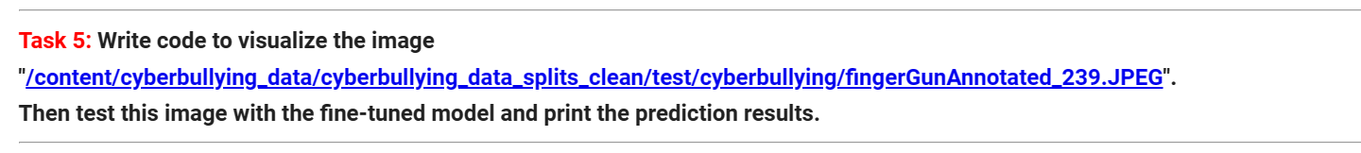

**Testing for another image with fine tuned model ft_model:**

**Another Image: Predicting on the whole Test_set using the fine tuned model called "ft_model":**

